|  |  |  |  |  |
| --- | --- | --- | --- | --- |
| GROUP |  |  |  | ACC |
| DATE OF LAB WORK |  |  |  |  |
| NAME | 1 | PRATAMA AJI NUR RAHMAN | D400154003 |  |
|  | 2 | AMNADUNY AKHARA | D400154006 |  |
|  | 3 | JESKI SAPUTRA | D400154009 | ACC DATE : |
|  | 4 | MILZAM WAFI AZHAR | D400154007 | REVISE DATE : |

MODULE 4

MANAGEMENT RESOURCE

1. PURPOSE
2. To knowing how to obtain control of a resource a task
3. To understanding how to counting semaphore for resource management in real time
4. TOOLS AND EQUIPMENT
5. Laptop
6. Arduino Uno
7. LED
8. Cable Jumper
9. BASIC THEORY

Most operating systems appear to allow multiple programs or threads to execute at the same time. This is called multi-tasking. In reality, each processor core can only be running a single program at any given point in time. A part of the operating system called the scheduler is responsible for deciding which program to run when, and provides the illusion of simultaneous execution by rapidly switching between each program.

The scheduler in a Real Time Operating System (RTOS) is designed to provide a predictable (normally described as deterministic) execution pattern. This is particularly interesting for embedded systems, like the Arduino devices, as embedded systems often have real time requirements.

Traditional real time schedulers, such as the scheduler used in [FreeRTOS](http://www.freertos.org/RTOS.html), achieve determinism by allowing the user to assign a priority to each thread of execution. The scheduler then uses the priority to know which thread of execution to run next. In FreeRTOS, a thread of execution is called a Task.

1. RESULT OF LAB WORK

D.1 Script Program

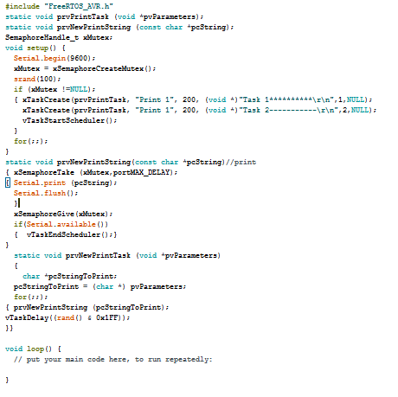

1. ANALYSIS

A function used to assign NUMBER ("TAG") to a TASK (Application) Controlled by a constant configUSE_APPLICATION_TASK_TAG.

configUSE_APPLICATION_TASK_TAG = 0 means the above function is off

configUSE_APPLICATION_TASK_TAG = 1 means the above function is active

A Macro (like function) called traceTASK_SWITCHED_IN () will be called automatically if the TAG Task NUMBER executes changed. At the time the macro is called it will be called the actual function named "vSetDigitalOutput" by using TAG ((int) pxCurrentTCB-> pxTaskTag NUMBER as parameter.

1. CONCLUSION

If there are resources (variables, hardware) that will be accessed more than one application (task) then required ... resource management, in order to avoid conflicts between applications.For example, if there are two applications that both use Serial Monitor to display the reading result, then Semaphore (mutex) is required to set access.